# **Real-Time Web Communication:**

# Polling vs. WebSockets

## **Traditional Approach: HTTP Polling**

HTTP polling is a technique where a client repeatedly requests information from a server at regular intervals to check for updates or new data.

### **How Polling Works:**

* Client sends a request to the server asking for new data
* Server responds with data (if available) or an empty response
* Client waits for a predetermined interval
* Process repeats continuously to simulate real-time updates

### **Disadvantages of Polling:**

1. **Resource Intensive**: Each poll creates a new HTTP connection with full headers
2. **Server Overload**: As user numbers increase (thousands/millions), servers stru§ggle with handling simultaneous polling requests
3. **Latency Issues**: Updates are only received after polling interval completes
4. **Bandwidth Waste**: Many requests return with no new data
5. **Scalability Challenges**: Difficult to scale efficiently with growing user base

### **Polling in Practice:**

When a service needs to maintain "real-time" data for many clients, polling can quickly become impractical. For example, if 10,000 users poll every 3 seconds, the server handles ~3,333 requests per second - just to maintain the illusion of real-time communication.

## **Modern Solution: WebSockets**

WebSockets represent a paradigm shift in web communication, establishing persistent, bidirectional connections between clients and servers.

### **How WebSockets Work:**

1. **Connection Establishment**: Begins with a standard HTTP request containing an "upgrade" header to switch protocols
2. **Persistent Connection**: Once established, a single TCP connection remains open
3. **Full-Duplex Communication**: Data can flow in both directions simultaneously
4. **Efficient Data Transfer**: Minimal headers after initial handshake
5. **Connection Termination**: Either side can close the connection when no longer needed

### **Advantages of WebSockets:**

1. **True Real-Time**: Immediate data transmission without polling delays
2. **Reduced Overhead**: Significantly lower bandwidth usage
3. **Server Efficiency**: No redundant connections and header processing
4. **Scalability**: Better performance under load compared to polling
5. **Better User Experience**: Instantaneous updates provide smoother interaction

### **WebSockets in Practice:**

WebSockets are ideal for applications requiring genuine real-time functionality like:

* Chat applications
* Live notifications
* Collaborative editing tools
* Real-time dashboards
* Online gaming
* Financial tickers

## **Implementation with Socket.IO**

Socket.IO is a popular library that simplifies WebSocket implementation with additional features:

* Fallback mechanisms for browsers/networks without WebSocket support
* Automatic reconnection
* Event-based communication model
* Broadcasting capabilities
* Room-based communication channels

Socket.IO abstracts away the complexity of managing WebSocket connections while providing a consistent API for developers.

## **Summary**

When building modern web applications with real-time features, WebSockets provide a significantly more efficient solution than polling. While polling creates numerous short-lived connections that tax server resources, WebSockets establish single persistent connections that enable immediate bidirectional communication.  
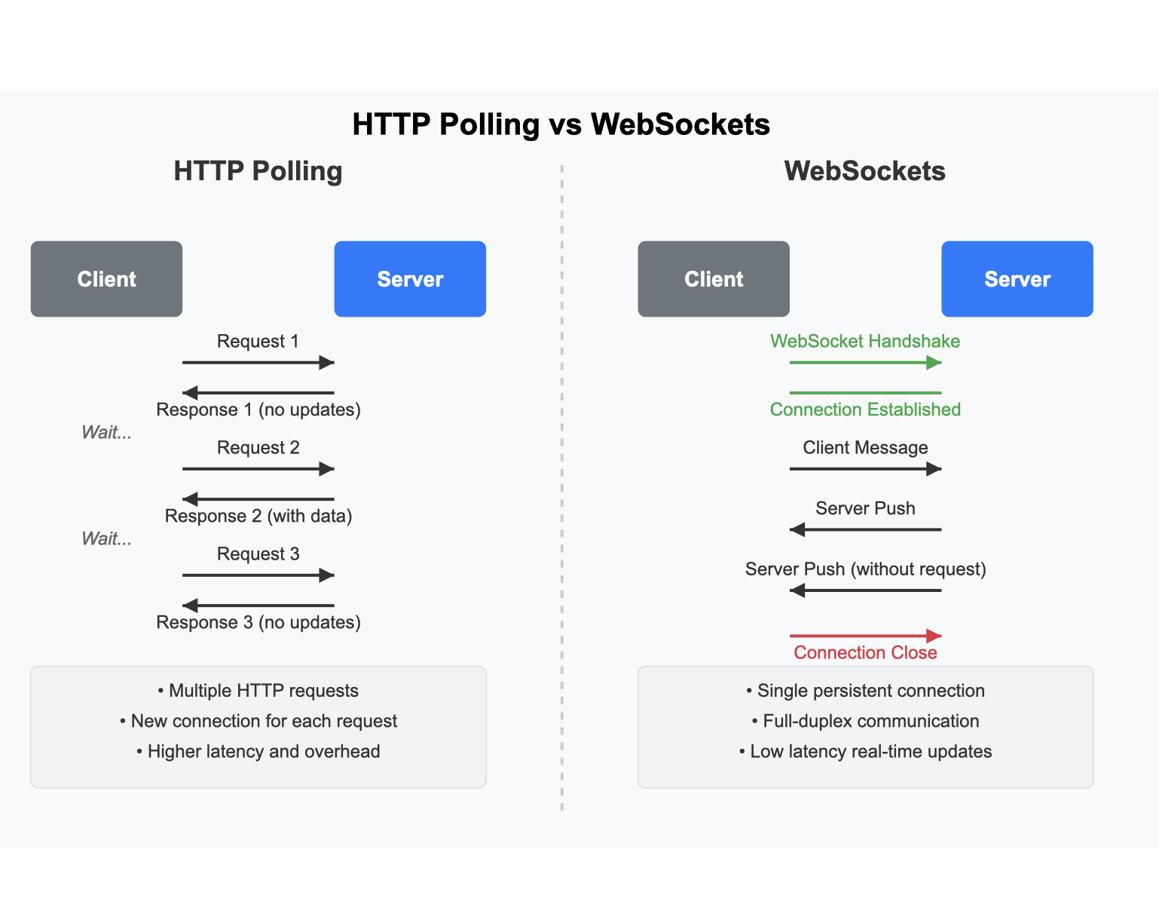

The transition from polling to WebSockets represents an architectural evolution in web communication, enabling truly interactive applications with minimal overhead.